BAYSTATE ORGANIC CERTIFIERS
100% GRASS-FED MANUAL

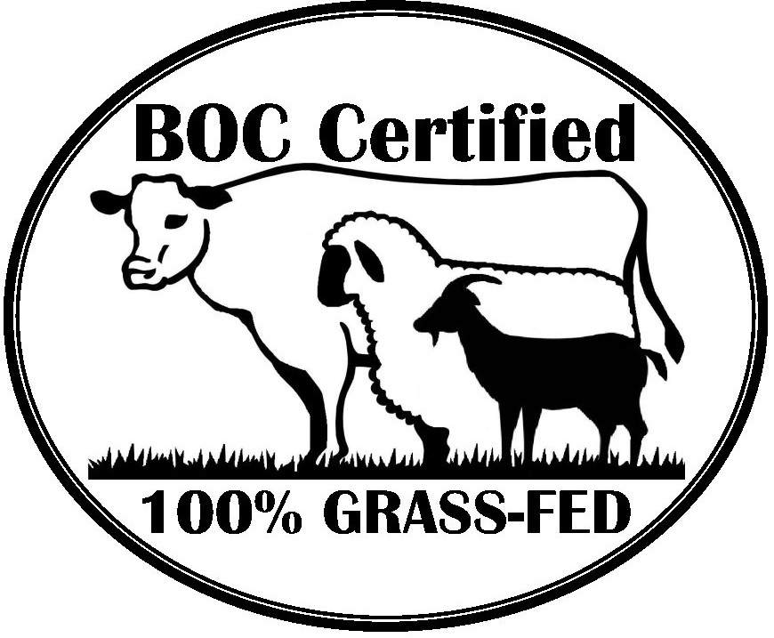
INTRODUCTION
The 100% Grass-Fed Certification Program establishes an optional additional certification scope to organic operations. The program standards apply to producers of ruminant livestock and to handlers of meat and dairy products derived from ruminant livestock.
Baystate Organic Certifiers is accredited by The Organic Plus Trust Inc. to conduct its 100% Grass-Fed certification program in response to membership interest in third-party verification of food products that are sourced from pasture. Throughout the development process, every effort was made to assure the quality and integrity of the standard. These standards were developed in conjunction with The Organic Plus Trust Inc. (OPT) and participating accrediting certification agencies (ACAs) through research of existing private certification programs, consultations with industry professionals, and information from scientific publications.
QUESTIONS AND ANSWERS
Q. Who is eligible to apply for the 100% Grass-Fed Certification Program?
A. Operations currently certified organic by any accredited certifying agency or applying for certification by Baystate Organic Certifiers under the USDA's National Organic Program.
Q. What types of operations can be certified under the 100% Grass-Fed Certification Program?
- All producers of ruminant livestock and handlers of meat and dairy products.
Q. Will my operation need to be inspected in order to be Grass-Fed certified?
- Yes. The on-site inspection will be conducted annually and occur simultaneously with your organic on-site inspection.
Q. How much will it cost?
A. You will be charged an annual Grass-Fed certification program fee. See current Baystate Organic Certifiers Grass-Fed Fee Sheet.
Q. How do I apply?
A. Contact Baystate Organic Certifiers for the forms and submit the completed form, along with the fee, to Baystate Organic Certifiers office.
Q. Once I am certified, how often do I need to renew my certification?
A. In order to maintain your certification, it must be renewed annually.
Q. Can I contract production and/or processing of my 100% Grass-Fed product to another certified organic operation even though it is not certified by Baystate Organic Certifiers?
A. Production of 100% Grass-Fed milk cannot be contracted out. Processing of 100% Grass-Fed products can be. The contracted operation is inspected and approved by Baystate Organic Certifiers. A supplementary form must be completed for each contracted operation and submitted, along with the additional certification fee, to Baystate Organic Certifiers.
Q. What happens if my operation does not comply with the 100% Grass-Fed Standards or program requirements?
A. If your operation is not in compliance, you will be given an opportunity to correct the noncompliance. If correction of the noncompliance is not possible, your application for certification will be denied, or your certification may be suspended. Operations suspended from the grass-fed program may correct the underlying noncompliances and reapply for grass-fed certification at any time.
Q. What are the benefits of becoming certified under the 100% Grass-Fed Certification Program?
A. Successful completion of the certification process means that your operation has been inspected and verified by Baystate Organic Certifiers, an independent third-party certification agency, to meet the requirements of the Baystate Organic Certifiers 100% Grass-Fed Standards. Your certified product can claim that it is certified under the 100% Grass-Fed Certification Program, and you may also use the OPT 100% Grass-Fed seal and Baystate Organic Certifiers 100% Grass-Fed seal on certified product labeling and marketing materials.

FEES
An administrative fee is assessed annually, in addition to the operation organic certification fees, in order to participate in the 100% Grass-Fed Certification Program.
While grass-fed inspections take place simultaneously with the organic certification inspections, Baystate Organic Certifiers reserves the right to charge any operation for additional inspection costs caused by an applicant’s failure to appear at the time agreed upon for inspection, or for additional inspection costs caused by an operation submitting an incomplete Organic System Plan. Charges will be limited to 100% of the inspection costs including labor, mileage, and travel expenses.
Additionally, a small fee will be assessed for using the OPT Program Seal usage on retail products. There is no additional fee for using the Baystate Grass-Fed seal on retail products.

GRASS-FED SEALS
Use of the OPT “100% Certified Grass-Fed Organic” seal is required for retail product packaging making 100% Grass-Fed claims. Use of the OPT seal is permitted to operations that have paid the assessed fee.
Use of the Baystate Organic Certifiers 100% Grass-Fed logo may be used in conjunction with the OPT seal but cannot be used as a substitute of the OPT logo. There is no additional fee assessed for using the regular Baystate logo or the Baystate 100% Grass-Fed seal.
STEPS TO CERTIFICATION

GRASS-FED STANDARDS
Part 1 – Terms Defined
Boot stage. Growth stage when a grass inflorescence is enclosed by the sheath of the uppermost leaf. ¹
In small grains, this stage of growth is identified on the Feekes Growth Sale as Stage 10. ²
Non-routine. Not a repetitive or continuing practice, such as the implementation of an operation’s system plan would be.
V10 stage. Growth stage of corn development when the stalk is in rapid growth phase accumulating dry
matter and nutrients. The tassel has begun growing rapidly as the stalk continues to elongate. ³
Vegetative state (pre-grain/pre-boot). Stage of growth prior to boot stage or grain development.
[1] Forage Information System, Oregon State University
[2] Managing Wheat by Growth Stage, Purdue University Extension
[3] Corn Growth Stage Development, University of Illinois Extension

Part 2 – Livestock Production
2.1 General. Livestock intended for “Baystate Organic Certifiers 100% Grass-Fed” certification of dairy or meat products must be certified organic.
2.2 Origin of Livestock
2.2.1 Livestock products that are to be sold, labeled, or represented as “Baystate Organic Certifiers 100% Grass-Fed” must be:
a. Born at the operation or purchased from an operation certified to this standard and maintained under this standard throughout the animal’s lifespan;
b. Once an entire distinct herd has converted to Grass-Fed production, all animals shall remain under Grass-Fed management.
c. All management practices must be documented, including a herd list that meets the requirements of 7 C.F.R. §205.236(c) and confirms status of Grass-Fed Organic animals.
2.3 Grazing Requirements and Livestock Feed
2.3.1 A certified operation shall graze all animals over six months of age on pasture throughout the grazing season, which shall not be less than 150 days per calendar year. The grazing season is not required to be continuous due to weather and season.
2.3.2 A certified operation shall provide no less than 60% Dry Matter Intake (DMI) derived from pasture, except that
a. Livestock may be fed milk prior to weaning.
b. Livestock under the age of 6 months may be fed certified organic grain on a non-routine basis for up to 3 years from implementation date of this standard, provided the operation maintains a written plan for how grain feeding will be terminated and that written plan is approved by Baystate Organic Certifiers.
c. Livestock may be fed the following supplemental non-forage feedstuffs, provided that:
i. Each use of restricted grain-free feedstuffs, even in routine, is necessary to support livestock nutritional stability and rumen welfare;
ii. No more than a single restricted feedstuff is provided per day;
iii. The operation maintains complete records of all restricted feedstuffs fed to animals;
iv. The restrictions on the allowed daily amount in the chart below are observed.
Organic Energy Supplement* | Supplement Dry Matter Percent | Maximum Allowed Per Day on Dry Matter Basis (lbs.) | Starch, %DM | Energy, M Cal/lb.
Sugar Cane Molasses | 88% | 4 | 0.5 | .98
Sugar Cane Dry Sugar | 100% | 4 | 0.5 | .98
Sugar beets, Whole | 20% | 5 | 2.5 | .79
Sugar beets, Pulp | 92% | 5 | 0.5 | .73
Carrots, Pulp | 92% | 5 | 5.74 | .77
Citrus, Pulp | 92% | 5 | 1.5 | .84
Alfalfa Pellets | 92% | 5 | 2 | .58
Kelp | 99% | No limit/Free Choice | n/a | n/a
*Organic Energy Supplements are mutually exclusive on any single day. The intake values were calculated using 3.5% body weight of a 1200-lb. ruminant animal.
d. Baystate Organic Certifiers will review other non-forage feedstuffs on an as needed basis per the following criteria:
i. Feedstuff must not be a prohibited in Part 2.3.5 of this standard.
ii. Feedstuff must not be starch-based.
iii. Feedstuff must not change the nutrient profile of the meat or milk product.
2.3.3 Agricultural products, including pasture and forage, must be certified organic and meet the
requirements of 7 CFR §205.237.
2.3.4 Livestock may be fed forage that consists of grasses (annual and perennial), forbs, legumes, brassicas, browse, cereal grain crops in their vegetative (pre-grain/pre-boot) state, provided that
a. Crops normally harvested for grain, including but not limited to corn, soybean, rice, wheat and oats, are foraged or harvested in the vegetative state. Forage may include seeds naturally attached to crops not normally harvested for grain (corn in pre-tassel stage, soybeans prior to bloom, cereal grains in pre-boot stage).
b. Grain crops have not matured to boot stage or later.
c. Corn has not matured past the V10 stage or into tassel stage.
2.3.5 Livestock may be fed trace vitamins and minerals in accordance with 7 CFR §205.603(d), provided that:
a. The material is permitted in organic livestock production.
b. The material is fed at labeled rates or does not exceed a rate within the normal range of consumption as prescribed by the manufacturer, a veterinarian, or qualified nutritionist.
c. The material is free of grain or grain carriers.
2.3.6 Livestock must not be fed the following feedstuffs:
a. Grain and grain by-products
b. Corn kernels or corn kernel by-products
c. Cake or meal feedstuffs
d. Concentrates
e. Food processing by-products or waste containing grain
f. Small grain or corn allowed to mature past the vegetative (pre-grain/pre-boot) state
2.4 Livestock Health Care
2.4.1 Livestock must be managed in accordance with 7CFR §205.238.
2.4.2 Operator must not withhold grain or other nutritional supplementation from a sick animal to preserve its “Baystate Organic Certifiers 100% Grass-Fed” status. All appropriate organic feedstuffs must be used to restore an animal to health when feedstuffs that are allowed under this standard fail. If grain supplementation is provided to an animal, the operator must,
a. Document the supplementation and notify Baystate Organic Certifiers.
b. Clearly identify the animal as not part of the Grass-Fed certified herd.
c. Not sell, label, or represent the animal or products from the animal as “Baystate Organic Certifiers 100% Grass-Fed”.
2.5. Pasture Management. Each operation certified to this standard must manage pastures in a manner that:
a. meets all the requirements set forth by the National Organic Program for pasture management,
b. allows for pasture rest and regrowth,
c. avoids overgrazing.
2.6 Split Production. Livestock certified as “Baystate Organic Certifiers 100% Grass-Fed” may be managed alongside organic livestock that are not certified as “Baystate Organic Certifiers 100% Grass-Fed” provided that the operator establishes management practices and identification methods to prevent misrepresentation of certified and non-certified “Baystate Organic Certifiers 100% Grass-Fed” livestock.
Part 3 – Handling
3.1 Products must be handled in accordance with 7 CFR §205.270.
3.2 Operator must establish practices that prevent commingling of products certified to this standard with products not certified to this standard.
Part 4 – Labeling
4.1 Single Ingredient products composed of dairy or meat produced by, or derived from, animals
in the grass-fed program shall be labeled: “Certified Grass-Fed Organic Dairy [product]” or “Certified Grass-Fed Organic Meat [product].”
4.2 Multi-ingredient products containing livestock ingredients certified in the grass-fed program shall be labeled in accordance with the labeling content classification system used in the NOP and the placement of the above referenced labeling language shall be applied analogously to the use of the word “organic” under the NOP. See 7 C.F.R. §§301-305.
4.3 If a multi-ingredient product is composed of 95%-99% grass-fed program-compliant ingredients it may be labeled “Certified Grass-Fed Organic [ingredient described]” provided, the remaining content of the product must comply with organic requirements and in no case shall it contain an ingredient in a form certified to the 100% Certified Grass-Fed Program and in the same form but not certified to the grass-fed program.
4.4 If a multi-ingredient product is composed of 70%-94% OPT Program-compliant ingredients it may be labeled “Contains Certified Grass-Fed Organic [ingredient described]” or “Made With Certified Grass-Fed Organic [ingredient described] “provided, the remaining content of the product must comply with organic requirements and in no case shall it contain an ingredient in a form certified to the grass-fed program and in the same form but not certified to the grass-fed program.
Part 5 – Recordkeeping
5.1 The operator must document and maintain records to demonstrate compliance to the standards, as required:
i. For livestock operations, the records that must be maintained are the following: a complete herd list, system plan documents, copies of organic certificates for any purchased feed and/or feed supplements, copies of grass-fed organic certificates for any purchased animals, healthcare records, pasturing records, DMI worksheets, any written non-routine feeding plans for organic grain fed to animals under 6 months of age, packaging/labeling as applicable, and any additional recordkeeping to demonstrate compliance.
ii. For handling and processing operations, the records that must be maintained are the following: system plan documents, copies of grass-fed organic certificates for purchased grass-fed organic ingredients, Organic Product Profiles, formulas/recipes for multi-ingredient products, process flow descriptions for production types, packaging and labeling as applicable, and any additional recordkeeping to demonstrate compliance.

GRASS FED POLICIES
Use of the Organic Plus Trust Inc 100% Grass-Fed Seal
The Organic Plus Trust Inc (OPT) 100% Grass-Fed seal may only be used to represent products certified by Baystate Organic Certifiers under the 100% Grass-Fed Certification Program. The OPT 100% Grass-Fed seal may also be used on marketing and public information materials such as flyers, posters, websites or signs to advertise the certification of an operation and/or the sale of products certified under the 100% Grass-Fed Certification Program. The use of the OPT 100% Grass-Fed seal is required for any labeled or packaged products that make any grass-fed claims. Packaging materials that bear the OPT 100% Grass-Fed seal must be submitted to Baystate Organic Certifiers for review and approval prior to use.
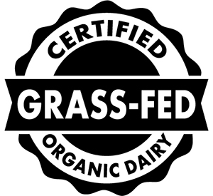
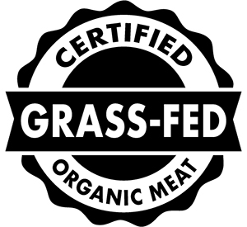

Use of Baystate Organic Certifiers 100% Grass-Fed Seal
The Baystate Organic Certifiers 100% Grass-Fed seal may only be used to represent products certified by Baystate Organic Certifiers under the 100% Grass-Fed Certification Program. The 100% Grass-Fed seal may also be used on marketing and public information materials such as flyers, posters, websites or signs to advertise the certification of an operation and/or the sale of products certified under the 100% Grass-Fed Certification Program. The use of the 100% Grass-Fed seal is voluntary and not required. Packaging materials that bear the Baystate Organic Certifiers 100% Grass-Fed seal must be submitted to Baystate Organic Certifiers for review and approval prior to use.
The Baystate Organic Certifiers 100% Grass-Fed seal may be used on product packaging, marketing materials, and public information materials. It must replicate the form and design below. Alternative colors and aspect ratios of the seal are prohibited. Contact Baystate Organic Certifiers for access.
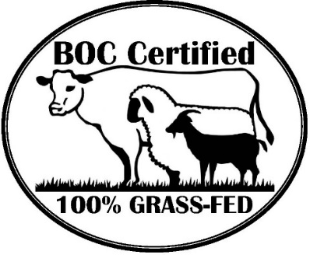
If Baystate Organic Certifiers has reason to believe that the Baystate Organic Certifiers 100% Grass-Fed seal has been used to misrepresent products as certified by Baystate Organic Certifiers, Baystate Organic Certifiers will investigate the situation. Baystate Organic Certifiers reserves the right to take legal action against misleading or unauthorized use of the Baystate Organic Certifiers 100% Grass-Fed seal.
Standards Revision
Baystate Organic Certifiers seeks to maintain a 100% Grass-Fed certification program of high quality and integrity. To ensure that the certification standard is current and accurate within an ever-changing
environment, Baystate Organic Certifiers will evaluate the 100% Grass-Fed certification program standards every 3 years.
Baystate Organic Certifiers will accept comments from certified operators and members regarding ways to improve this standard. These comments will be taken into consideration during the periodic evaluation process.

GRASS-FED CERTIFICATION PROGRAM POLICIES
Compliance
Operations certified to the Baystate Organic Certifiers 100% Grass-Fed Standards must comply with all provisions within the standards. If Baystate Organic Certifiers has reason to believe, based on the on-site inspection and a review of the information provided by the operator, that an operation is not able to comply or is not in compliance the standards, Baystate Organic Certifiers shall provide written notification of noncompliance to the operation. When the operation demonstrates that each noncompliance has been resolved, Baystate Organic Certifiers will send the operation a written notification of noncompliance resolution. When correction of a noncompliance is not possible, Baystate Organic Certifiers may issue a denial of certification to an applicant or may issue a proposed suspension. Operations suspended from the grass-fed program may correct the underlying noncompliances and reapply for grass-fed certification at any time.
Certification of Contracted Operations
A certified organic grass-fed operation may contract their processing to another certified organic operation, only if the following aspects of the contracted operation are verified and approved by Baystate Organic Certifiers:
- Compliance with NOP Regulations
- Compliance with the 100% Grass-Fed Organic Certification Standards
The contracted organic operation cannot be used to produce 100% Grass-Fed Organic milk but can be contracted for the handling of 100% Grass-Fed Organic products. The contracted organic operation must be inspected and approved by Baystate Organic Certifiers prior to using their services to process 100% Grass-Fed Organic products. The contracted organic operation must be inspected annually by Baystate Organic Certifiers.
The contracted operation will not be issued a certificate of any type from this program. The contracted operation is precluded from the marketing of 100% Grass-Fed Organic products within this program and must not use the name or any of the Grass-Fed seals offered in this program on any products or marketing materials. Marketing privileges are reserved solely for use by the grass-fed operation. The grass-fed operation is fully responsible for all handling performed by the contracted organic operation and will be subject to sanctions in the event of noncompliances of the contracted organic operation. Fees will be assessed to the grass-fed operation.

